Wood modification in ’countryname’
First Author¹, Second Author², Third Author³
¹ Address of first author, including country, affiliation, and email address
² Same for second author
³ Same for subsequent authors

Keywords: please provide a maximum number of 5 keywords here
Introduction
The paper should be sent to Giacomo.goli@unifi.it no ater than February the 11th. Please respect this deadline. Add the body text here with a general introduction on the situation of the country. If possible, please prepare your manuscript using ‘MS Word’ word processing software. The document should be saved under the first authors name, for example Jones.docx or Smith et al.doc. It can be saved either as doc or docx format. All pictures, tables, and figures should be embedded in the text and centred. Multiple figures should be inside tables. Top and margin is 3.5 cm, bottom margin and left margins are 3 cm, and the right margin is 2.5 cm. Do not place any text outside of this area. Do not include page numbers, they will be added later. Do not include headers and footers. The paper (regardless on the type of presentation) can be two pages long (including references). Please do not exceed these page limits.
All manuscripts should be in English. Metric units (SI) should be used. The point (.) should be used as decimal separator Should the authors use tables or figures from other publications, it is assumed that permission has been obtained to do so.

Modification technologies and production volumes
Table 1 should be filled for every country.

Table 1: Wood modification technologies, producers, companies and production volumes
Wood modification technology | Producer, process short description and website | Annual volumes produced and companies involved in the process

This sections should be followed by practical examples.

Practical examples
Please add here practical examples.
Figures should be referred to in text as Fig. 1, ths same for tables, and should be presented as part of the text. A descriptive title should be given bellow the figures and above the tables in Calibri 10 pt.

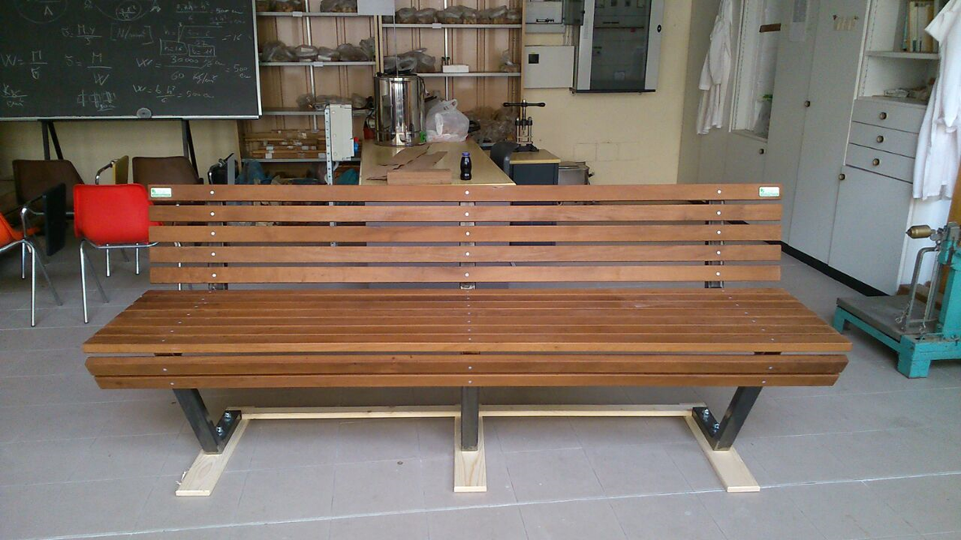 | 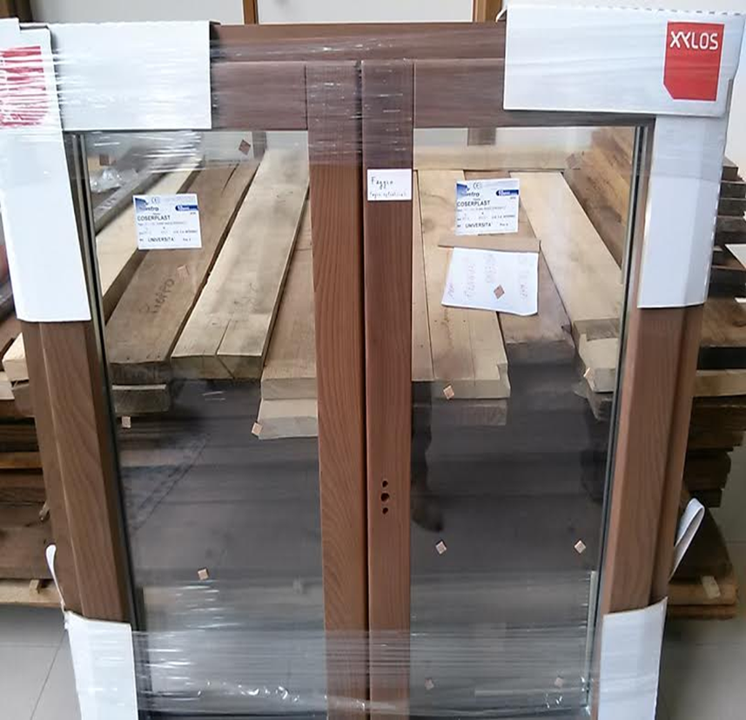
a | b
Figure 1: Thermally modified alder wood bench (a) and hermally modified beech wood window (b).

References
Please cite only the most important references (in Calibri 10 pt). Do not abbreviate journal titles. Cite references in the text using the author’s last name and date of publication as follows (Murphy 1990, Jones and Smith 1989, Davis et al. 1999).

Example:

Buschbeck L., Kehr E., Jensen U. 1961a. Untersuchungen über die Eignung verschiedener Holzarten und Sortimente zur Herstellung von Spanplatten – 1. Mitteilung: Rotbuche und Kiefer. Holztechnologie, 2, 2: 99–110
Kollmann F., Kuenzi W. E., Stamm J. A. 1975. Principles of Wood Science and Technology – Volume II: Wood Based Materials. Berlin, Heidelberg, New York, Tokyo, Springer–Verlag: 312–550
Xu W., Suchsland O. 1998. Variability of particleboard properties from single– and mixed–species processes. Forest Products Journal, 48, 9: 68–74

Acknowledgments:

